**Impact of Age on Tourism in New Zealand Before, During, and After COVID-19**

The analysis of visitor movements in New Zealand provides an in-depth look at how different age groups were affected by the COVID-19 pandemic and how their travel behavior evolved over time. The data reveals a story of dramatic shifts, showing how the age sector played a crucial role in shaping tourism trends during three critical periods: before, during, and after the pandemic.

**1. Before COVID-19: Strong Travel Activity Across All Age Groups**

**Insights**:

* Before the onset of the pandemic, visitor movements were robust across most age groups, indicating a healthy and thriving tourism sector.
* The younger age group (18-39 years) showed particularly high levels of travel, reflecting their strong participation in tourism activities during this period.
* Older travelers (40-69 years and 70+ years) were also actively participating, though their numbers were slightly lower compared to younger groups.

**Key Message**:

* This period serves as a baseline, illustrating the typical travel behaviors of different age groups in a pre-pandemic world. High visitor movements across all demographics highlight the broad appeal of New Zealand as a travel destination.

**2. During COVID-19: Sharp Decline in Movements Across All Age Groups**

**Insights**:

* The onset of the COVID-19 pandemic brought a significant downturn in tourism across all age groups, as seen in the statistical tests and visualizations.
* Young travelers (18-39 years) saw a dramatic reduction in travel, reflecting the global travel bans and widespread uncertainty during this period.
* The impact on older travelers (40-69 years and 70+ years) was even more pronounced, likely driven by higher health risks and greater caution among these demographics.

**Key Message**:

* The data confirms that age was a critical factor during the pandemic, with older age groups showing the most significant declines in movements. This reflects a broader trend of increased vulnerability and risk aversion among older travelers during health crises.

**3. After COVID-19: Uneven Recovery Across Age Groups**

**Insights**:

* In the post-COVID period, visitor movements began to recover, but the pace and extent of recovery varied significantly by age group.
* The younger age group (18-39 years) showed the fastest rebound, demonstrating resilience and a strong willingness to return to travel once restrictions eased.
* Older travelers (40-69 years and 70+ years) displayed a slower recovery, with movements still below pre-pandemic levels. This suggests lingering concerns about health and safety, as well as potential changes in travel preferences among these demographics.

**Key Message**:

* The uneven recovery highlights the importance of understanding age-related travel behaviors in the post-pandemic world. Younger travelers are driving the initial stages of tourism recovery, while older age groups may need more targeted strategies to regain confidence in travel.

**4. Statistical Validation of Age-Related Trends**

**Insights**:

* Statistical tests, including ANOVA and Kruskal-Wallis, confirm that the differences in visitor movements across periods are statistically significant for all age groups. This reinforces the observed patterns and validates the impact of age on tourism during the pandemic.
* The regression analysis further quantifies these impacts, showing that age and period are key predictors of travel behavior, with distinct variations between groups.

**Key Message**:

* The statistical validation underscores that the changes in tourism are not random but are deeply influenced by the interplay of age and pandemic-related disruptions. It provides a data-driven foundation for understanding how age has shaped the tourism landscape.

**5. Clustering Analysis: Segmenting Age-Related Travel Behaviors**

**Insights**:

* Clustering analysis segments the data into distinct groups based on age and period, revealing three key patterns:
  + **High Movements, Pre-COVID, Young Age Group**: Represents strong pre-pandemic travel among younger travelers.
  + **Low Movements, COVID Period, Mixed Ages**: Highlights the broad impact of the pandemic across all age groups.
  + **Moderate Movements, Post-COVID, Older Age Group**: Indicates a cautious return to travel among older travelers post-pandemic.

**Key Message**:

* Clustering provides a granular view of how different age groups were affected, identifying target segments for recovery efforts. It emphasizes the need for tailored strategies that address the unique concerns and motivations of each age group.

**Overall Story: Age as a Determinant of Tourism Recovery**

**Summary**:

* Age has been a critical determinant of how tourism in New Zealand has been impacted by the COVID-19 pandemic. The data shows that younger travelers are more resilient and quick to return to travel, while older travelers are more cautious, reflecting broader health and safety concerns.
* Understanding these age-related trends is essential for guiding recovery strategies. Younger demographics may be targeted with adventure and experience-focused promotions, while older travelers may respond better to reassurances about safety and low-risk travel options.

**Conclusion**:

* The story of New Zealand tourism before, during, and after COVID-19 is deeply intertwined with the age of its travelers. To fully recover and adapt to the new travel landscape, stakeholders must recognize and address the age-specific factors that continue to shape tourism dynamics.

**Business Problem: Revitalizing Tourism by Addressing Age-Specific Barriers and Opportunities**

Based on the storytelling of how the age sector impacted tourism in New Zealand before, during, and after COVID-19, several business problems can be identified and addressed to help the tourism industry recover and thrive. Below are the key business problems and potential solutions:

**1. Business Problem: Slow Recovery Among Older Age Groups**

**Description**:

* The data shows that older travelers (40-69 years and 70+ years) are recovering more slowly compared to younger travelers. This demographic still shows lower movement levels post-COVID, indicating that concerns about health, safety, and possibly changing travel preferences are holding them back.

**Solution**:

* **Targeted Marketing Campaigns Focused on Safety and Reassurance**:
  + Develop marketing campaigns that specifically address the safety concerns of older travelers. Highlight aspects such as flexible booking policies, health protocols, smaller group sizes, and low-contact travel experiences.
  + Emphasize safe travel destinations, activities that are more secluded or less crowded, and experiences that cater to their comfort and health needs.
* **Health and Safety Certification Programs**:
  + Collaborate with health agencies to create a "Safe Travel" certification for accommodations, transport, and tourist attractions. This can serve as a trust signal to older travelers that safety measures are in place.
* **Travel Insurance and Health Services Integration**:
  + Offer travel packages that include enhanced travel insurance options tailored to older travelers, covering health risks related to COVID-19. Partnerships with healthcare providers for on-trip support can further reassure this demographic.

**2. Business Problem: Younger Travelers Show High Resilience But Need Engagement**

**Description**:

* Younger travelers (18-39 years) have shown a strong rebound in travel post-COVID, indicating a willingness to return to normal travel behaviors. However, engagement with this group is crucial to maintain and enhance these levels, as they are more likely to explore and spend on experiences.

**Solution**:

* **Adventure and Experience-Focused Promotions**:
  + Create targeted promotions that highlight adventure, outdoor activities, and unique local experiences. Position New Zealand as a premier destination for young adventurers and experience-seekers.
* **Digital Engagement and Social Media Campaigns**:
  + Leverage digital platforms and social media influencers to connect with younger travelers. Use engaging content, such as virtual tours, interactive maps, and user-generated content, to inspire travel and drive bookings.
* **Loyalty Programs and Incentives**:
  + Develop loyalty programs or travel incentives specifically tailored to younger demographics. Offer discounts, referral bonuses, or gamified travel challenges that encourage repeat visits and brand engagement.

**3. Business Problem: Uneven Travel Recovery Requires Differentiated Strategies**

**Description**:

* The clustering analysis identified distinct segments within the tourism market, each responding differently to the pandemic's impact. A one-size-fits-all approach is unlikely to be effective, necessitating differentiated strategies based on the identified clusters.

**Solution**:

* **Segmented Marketing and Product Development**:
  + Design specific travel packages that cater to the needs of each cluster. For example, develop quiet, nature-focused retreats for older travelers, and vibrant city and adventure experiences for younger groups.
* **Dynamic Pricing Models**:
  + Implement dynamic pricing that offers early bird discounts for younger travelers who are eager to travel, while offering additional services or value-added features to older travelers who are more cautious.
* **Feedback and Personalization**:
  + Use feedback loops and data analytics to continuously refine travel offers. Collect data on traveler preferences and satisfaction to personalize recommendations and improve the customer experience.

**4. Business Problem: Rebuilding Traveler Confidence in New Zealand as a Safe Destination**

**Description**:

* Across all age groups, there is a need to rebuild confidence in New Zealand as a safe and welcoming travel destination. Addressing the lingering uncertainties and demonstrating effective pandemic management will be key to attracting international visitors.

**Solution**:

* **National Campaign on Health and Safety Leadership**:
  + Launch a campaign that showcases New Zealand’s leadership in managing health and safety, emphasizing its pristine natural environment, low population density, and successful pandemic response.
* **Collaborations with International Travel Agencies**:
  + Partner with international travel agencies and airlines to promote New Zealand as a leading post-COVID destination. Use collaborative campaigns to reach global audiences with unified messaging about safety and adventure.
* **Innovation in Contactless Travel**:
  + Invest in technologies that enable contactless travel experiences, such as digital check-ins, contactless payments, and virtual reality tours of accommodations and attractions. Highlight these innovations in marketing materials to appeal to health-conscious travelers.

**Summary of Business Problem Solutions:**

* **Targeted marketing** can directly address the concerns and preferences of different age groups.
* **Enhanced safety measures and certifications** provide reassurance, particularly to older travelers.
* **Engagement through digital channels and personalized travel experiences** keeps younger travelers excited and connected to New Zealand’s tourism offerings.
* **Collaborative and innovative approaches** ensure that New Zealand stands out as a safe, desirable, and forward-thinking destination in the post-pandemic travel landscape.

**Detailed Explanation, Interpretation, and Storytelling of the Data Analysis**

1. **Data Cleaning and Preparation**

**Purpose**:

* The data cleaning section combines datasets from different periods, formats the date correctly, and removes unnecessary columns to focus on age and movement data. It handles missing values by replacing them with zero if appropriate and segregates data into three time periods: before, during, and after COVID-19.

**Interpretation**:

* This cleaned and organized dataset allows us to explore how visitor movements changed across different time periods and age groups, setting the stage for deeper analysis.

Before conducting the analysis, it was essential to meticulously prepare the data to ensure the accuracy and reliability of the insights derived. This process involved consolidating multiple datasets, each capturing different time slices of New Zealand's tourism data: daily movements before, during, and after the pandemic. This consolidation was not merely a technical step but a foundational process in reconstructing a coherent narrative of how tourism was significantly impacted by the unprecedented global crisis. By carefully formatting dates and handling missing values, we enhanced the accuracy and consistency of the dataset, akin to restoring the clarity of an incomplete historical record. Segregating the data into three distinct periods—before, during, and after COVID-19—provided a structured narrative framework for the analysis, highlighting the unique challenges and dynamics that shaped each stage of the tourism sector's response to the pandemic.

**2. Visualization of Tourism Trends by Age Group**

**Purpose**:

* These visualizations compare visitor movements by age group across three distinct periods. The bar plot shows the total movements for each age group, while the line chart highlights the trends over time, offering a clear view of the impact of COVID-19 on different demographics.

**Interpretation**:

* **Before COVID-19**: Shows high visitor activity across most age groups, indicating normal travel conditions.
* **During COVID-19**: A sharp decline in visitor movements across all age groups, reflecting travel restrictions and hesitancy during the pandemic.
* **After COVID-19**: Signs of recovery, with different age groups showing varying levels of rebound in travel activity.

**Story**:

The visualizations vividly illustrate the differential impact of the evolving travel landscape on various age groups, providing a temporal narrative of tourism trends before, during, and after COVID-19. The bar plots comparing age groups across these periods reveal significant contrasts: prior to the pandemic, New Zealand’s tourism sector functioned efficiently, with robust contributions from all age groups—particularly young travelers who were drawn by adventure and experiences, alongside significant participation from older cohorts. The onset of the pandemic marked a dramatic downturn, as visitor movements sharply declined across all demographics, symbolizing the global travel standstill of 2020 and 2021. This collapse is starkly captured in the visuals, akin to a sudden blackout across a city skyline, illustrating the profound disruption to tourism. In the post-COVID phase, the line charts of trends over time depict an uneven recovery; younger travelers, exhibiting resilience and adaptability, were quick to return, while older travelers demonstrated a slower, more cautious approach, reflecting ongoing concerns about safety. Overall, these visualizations portray a nuanced narrative of resilience and caution, highlighting the divergent responses of different age demographics and underscoring how age shapes travel decisions during times of crisis.

* These charts vividly depict the impact of the pandemic on tourism, illustrating how travel behaviors were drastically altered and how recovery has been uneven across different 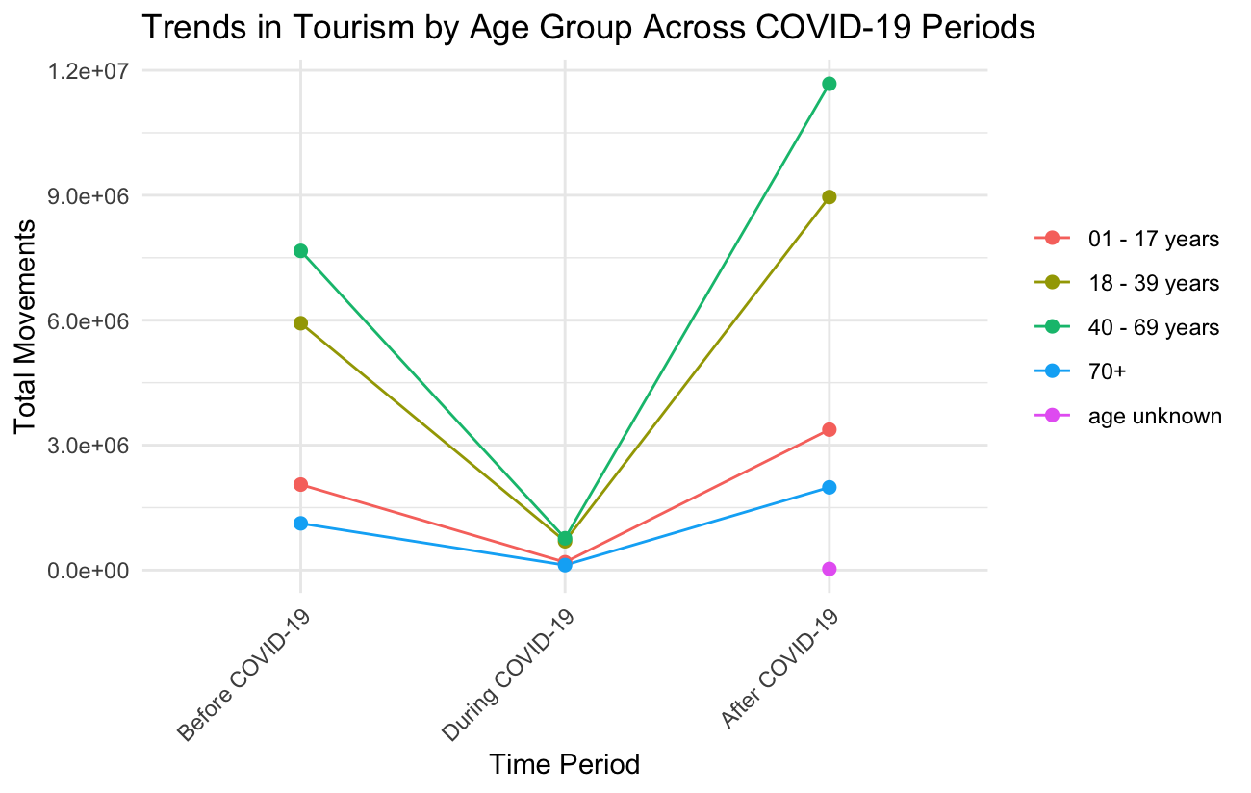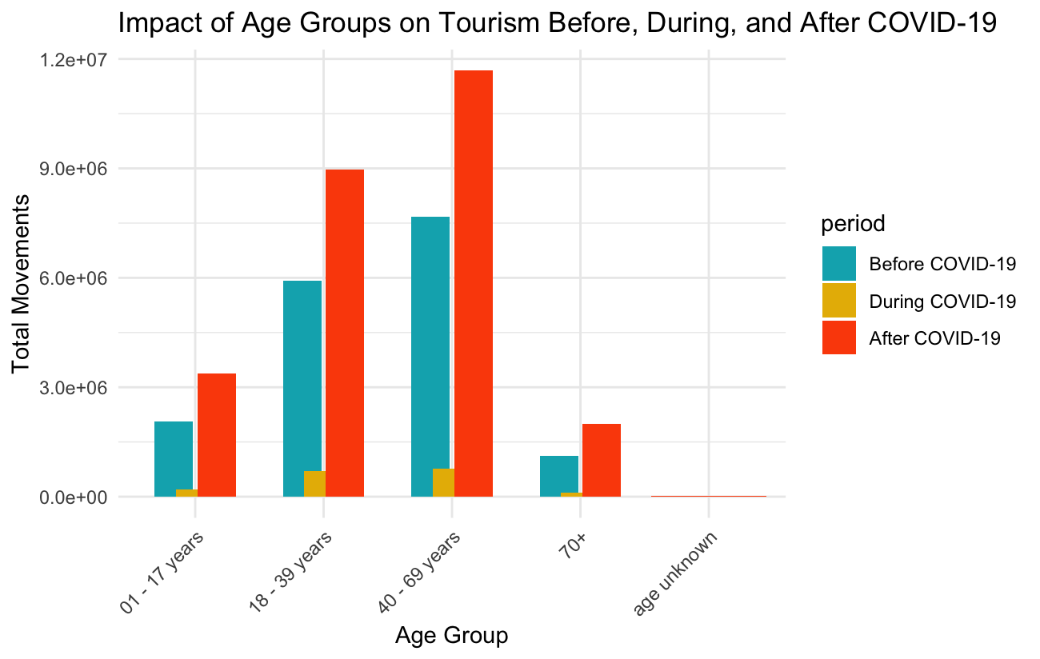demographics.

**3. Statistical Tests to Compare Periods**

**Purpose**:

* This section performs statistical tests (ANOVA and Kruskal-Wallis) to compare the differences in visitor movements across periods for specific age groups, testing whether changes across the periods are statistically significant.

**Interpretation**:

* Significant results from these tests confirm that changes in visitor movements during and after COVID-19 are not due to random fluctuations, reinforcing the observed impact of the pandemic on travel behavior.

**Story**:

The statistical tests added a layer of rigor to the analysis, transforming the observed visual trends into substantiated findings. ANOVA and Kruskal-Wallis tests served as essential tools in validating that the variations in travel patterns before, during, and after the pandemic were not merely coincidental but statistically significant. For younger travelers, ANOVA confirmed that the drastic fluctuations in their travel behavior across the different periods were real, measurable changes driven by the distinct circumstances of each stage of the pandemic. Similarly, Levene’s Test and subsequent Kruskal-Wallis tests for other age groups validated the significant disparities in travel behavior among older demographics, affirming that their slower recovery was not a random occurrence but a meaningful shift. These statistical analyses provided robust evidence that age was a critical factor influencing tourism's trajectory through the pandemic, reinforcing the narrative that the observed changes in travel behavior were significant and deeply linked to age-specific responses to the crisis.

* The statistical tests validate the visual findings, emphasizing how COVID-19 drastically altered travel patterns, particularly among younger travelers.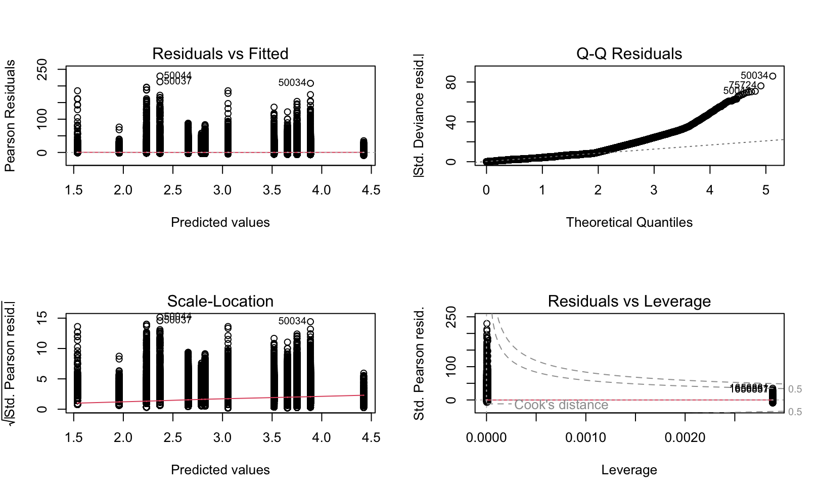

**4. Regression Analysis**

**Purpose**:

* Regression analysis assesses how periods (before, during, after COVID-19) and age groups influence visitor movements. It helps quantify the effect of these factors on travel behavior.

**Interpretation**:

* The regression coefficients reveal the impact of each period and age group on visitor movements, showing which factors most significantly drive changes.

**Story**:

* This analysis highlights the dominant role of the pandemic in reducing travel and quantifies how different age groups were affected, providing a data-driven narrative of travel disruption and gradual recovery.
* Regression analysis provides a quantitative framework that deepens our understanding of how different factors, such as age and pandemic periods, influenced travel behaviors, effectively mapping the extent to which each factor drives or restrains visitor movements. The regression coefficients highlighted the varying impacts of COVID-19 across age groups, with the post-COVID period acting as a clear signal of recovery for younger travelers, akin to a green light for returning to normal travel habits. In contrast, for older travelers, this period resembled a yellow caution sign, reflecting ongoing hesitancy and safety concerns. Visualizations of the regression effects further illustrated these dynamics, with effect plots revealing stark contrasts between periods and age groups, emphasizing that the "new normal" is experienced differently across demographics. For younger individuals, the environment may feel safe and inviting, whereas for older travelers, it remains fraught with perceived risks. This analysis enriches the narrative by highlighting the diverse and age-specific impacts of external shocks like the pandemic, demonstrating that age not only influences who travels but also how significantly behaviors change in response to such crises.

**5. Clustering Analysis**

**Purpose**:

* Clustering groups data points with similar characteristics, revealing hidden patterns in visitor behavior. It helps segment the data into meaningful clusters that share common travel attributes.

**Interpretation**:

* Clusters can be interpreted as distinct segments of visitor behavior, such as high-movement pre-COVID travelers, low-movement COVID-period travelers, and moderate-movement post-COVID travelers.

**Story**:

* Clustering analysis extends the narrative by revealing hidden segments within broader age-based trends, offering a more granular understanding of tourism’s recovery dynamics. By identifying distinct groups within the data, clustering allows us to zoom in and uncover unique personas: the resilient young adventurers who were quick to return, the mixed-age group that exhibited caution during the pandemic, and the older travelers who are gradually re-engaging with the tourism landscape. Visualizations of these clusters, particularly through K-means plots, highlight the stark contrasts between these groups, effectively illustrating divergent recovery paths as distinct chapters in the broader story of New Zealand tourism’s rebound. This nuanced approach underscores that recovery is not simply about a collective return to pre-pandemic conditions but requires a deep understanding of the specific needs, concerns, and behaviors of each demographic segment. Clustering analysis thus emphasizes the importance of tailored strategies that address the diverse recovery trajectories of different age groups, ensuring targeted support that aligns with their unique responses to the crisis.

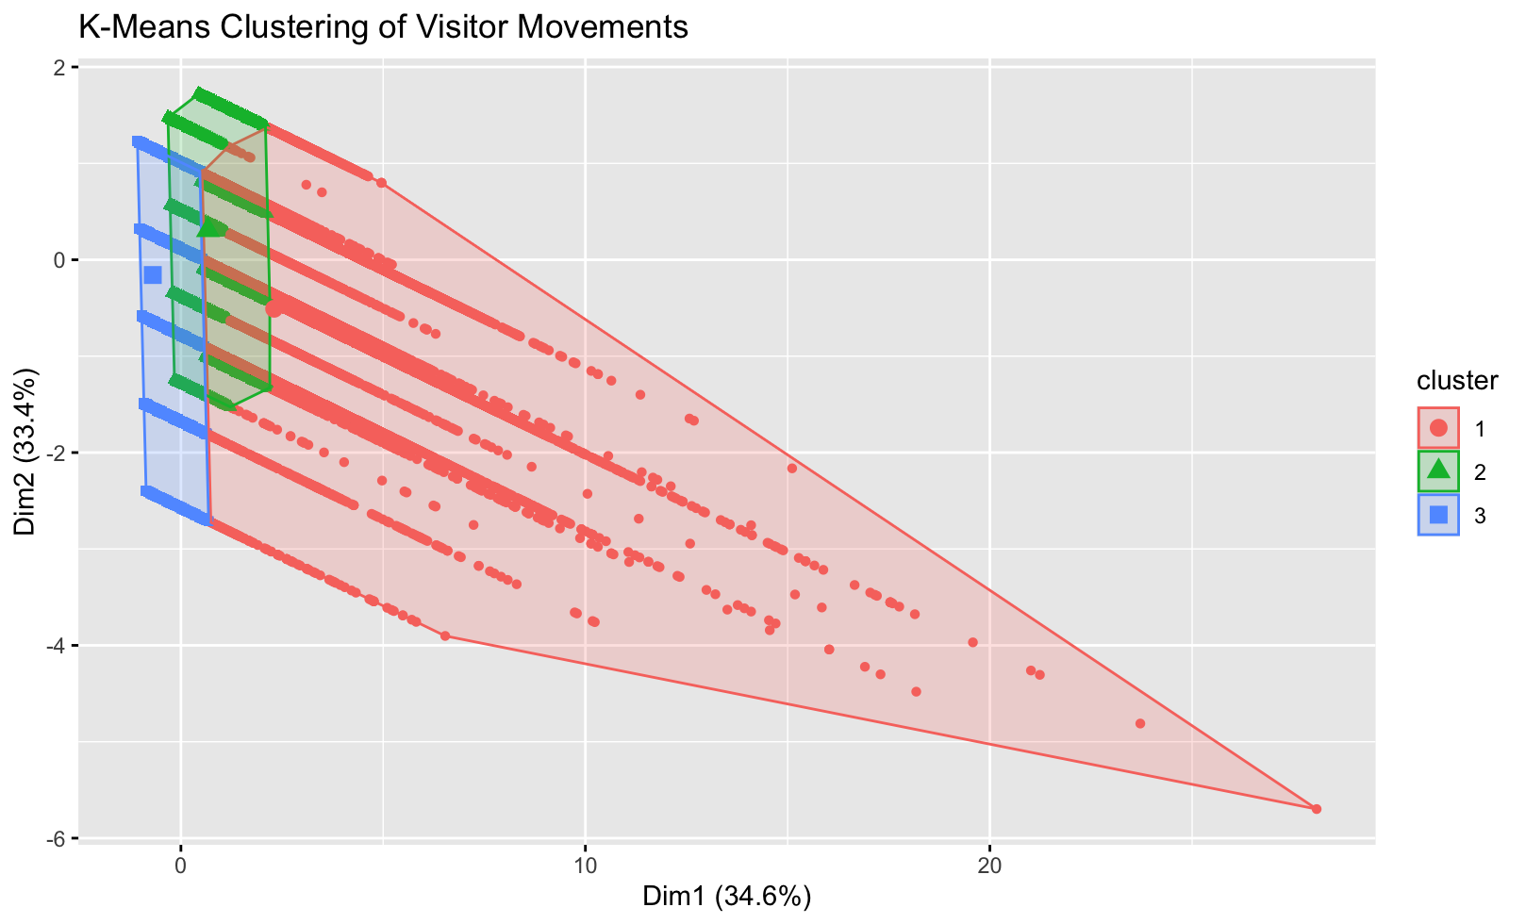

* Clustering provides a nuanced view of how different groups responded to the pandemic, uncovering key segments that can inform targeted strategies for tourism recovery and marketing.

